This homework assignment is based on Chapter 9

**There are 3 print screens each worth 33.3%**

1. Complete the Telemarketing Phone Number List Program

**#1 Print screen the code with the output below here**

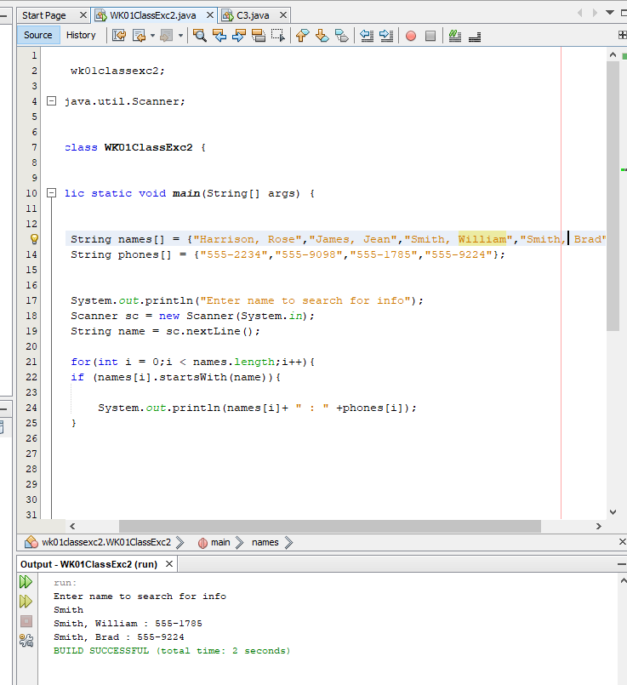

1. Complete the Check Writer Program

**#2 Print screen the code with the output below here**

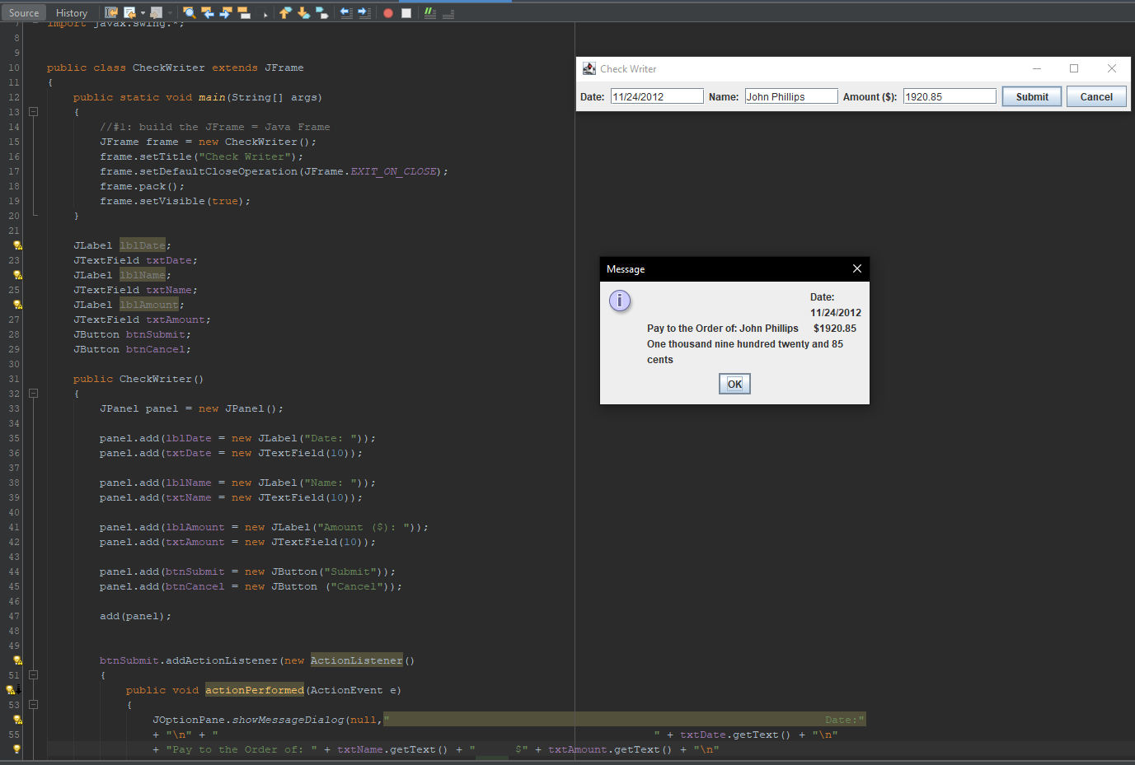

1. Complete the Sum of Integers in a String program.

**#3 Print screen the code with the output below here**

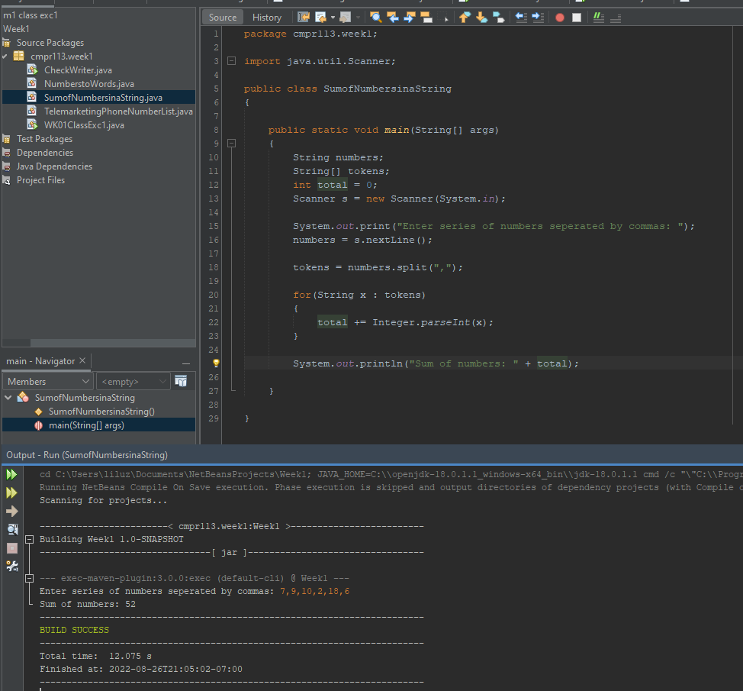

**Submit this document to Module 1 Homework #1**